TASK 1: Prediction Using Supervised ML

Aim is to predict the score of a student if he/she studies for 9.25 hrs/day

Author: Kirti Jain

Import the Dataset
In [88]:
#importing the relevant libraries
import numpy as np
import pandas as pd
import matplotlib.pyplot as plt
In [64]:
data= pd.read_csv("https://raw.githubusercontent.com/AdiPersonalWorks/Random/master/student_scores%20-%20student_scores.csv")
data
Out[64]:
 | Hours | Scores
0 | 2.5 | 21
1 | 5.1 | 47
2 | 3.2 | 27
3 | 8.5 | 75
4 | 3.5 | 30
5 | 1.5 | 20
6 | 9.2 | 88
7 | 5.5 | 60
8 | 8.3 | 81
9 | 2.7 | 25
10 | 7.7 | 85
11 | 5.9 | 62
12 | 4.5 | 41
13 | 3.3 | 42
14 | 1.1 | 17
15 | 8.9 | 95
16 | 2.5 | 30
17 | 1.9 | 24
18 | 6.1 | 67
19 | 7.4 | 69
20 | 2.7 | 30
21 | 4.8 | 54
22 | 3.8 | 35
23 | 6.9 | 76
24 | 7.8 | 86
In [65]:
#specify rows and coloumn
data.shape
Out[65]:
(25, 2)
In [66]:
#name of columns
data.columns
Out[66]:
Index(['Hours', 'Scores'], dtype='object')
In [67]:
#check for null values
data.isnull()
Out[67]:
 | Hours | Scores
0 | False | False
1 | False | False
2 | False | False
3 | False | False
4 | False | False
5 | False | False
6 | False | False
7 | False | False
8 | False | False
9 | False | False
10 | False | False
11 | False | False
12 | False | False
13 | False | False
14 | False | False
15 | False | False
16 | False | False
17 | False | False
18 | False | False
19 | False | False
20 | False | False
21 | False | False
22 | False | False
23 | False | False
24 | False | False
In [68]:
data.isnull().sum()
Out[68]:
Hours 0
Scores 0
dtype: int64
In [69]:
data.describe()
Out[69]:
 | Hours | Scores
count | 25.000000 | 25.000000
mean | 5.012000 | 51.480000
std | 2.525094 | 25.286887
min | 1.100000 | 17.000000
25% | 2.700000 | 30.000000
50% | 4.800000 | 47.000000
75% | 7.400000 | 75.000000
max | 9.200000 | 95.000000

Visualize and Analyse the Dataset
In [70]:
#Scatter plot of Number of hours studied and score obtained
plt.scatter(data['Hours'],data['Scores'],color='green')
plt.title('Hours studied and Scores ')
plt.xlabel('Number of hours studied')
plt.ylabel('Scores obtained')
plt.show()
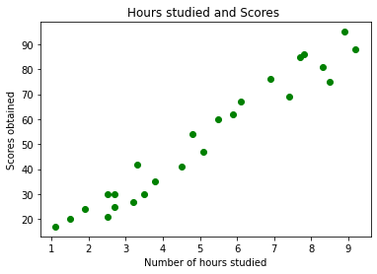
In [71]:
#check the correlation between two coloumns
data.corr()
Out[71]:
 | Hours | Scores
Hours | 1.000000 | 0.976191
Scores | 0.976191 | 1.000000
From the above graph and data, we can clearly see that there is a positive linear relation between the number of hours studied and scores.

Prepare the Data
In [72]:
#divide the data into input and output
x=data.iloc[:, :1].values
y=data.iloc[:, 1:].values
In [73]:
#Hours studied
x
Out[73]:
array([[2.5],
[5.1],
[3.2],
[8.5],
[3.5],
[1.5],
[9.2],
[5.5],
[8.3],
[2.7],
[7.7],
[5.9],
[4.5],
[3.3],
[1.1],
[8.9],
[2.5],
[1.9],
[6.1],
[7.4],
[2.7],
[4.8],
[3.8],
[6.9],
[7.8]])
In [74]:
#scores obtained
y
Out[74]:
array([[21],
[47],
[27],
[75],
[30],
[20],
[88],
[60],
[81],
[25],
[85],
[62],
[41],
[42],
[17],
[95],
[30],
[24],
[67],
[69],
[30],
[54],
[35],
[76],
[86]], dtype=int64)

Design and Train the Machine Learning Model
In [75]:
#split the data
from sklearn.model_selection import train_test_split
x_train, x_test, y_train, y_test= train_test_split(x,y,test_size=0.3,random_state=42)
In [76]:
from sklearn.linear_model import LinearRegression
model= LinearRegression()
model.fit(x_train, y_train)
Out[76]:
LinearRegression()
In [77]:
model.coef_
Out[77]:
array([[9.71054094]])
In [78]:
model.intercept_
Out[78]:
array([2.79419668])

Visualize the Model
In [79]:
#plotting the regression line
#y=mx+c
regression_line= model.coef_*x+model.intercept_
plt.scatter(x,y,color='red')
plt.plot(x,regression_line,color='black')
plt.title(' Number of hours studied and scores obtained')
plt.xlabel('Hours')
plt.ylabel('Scores')
plt.show()
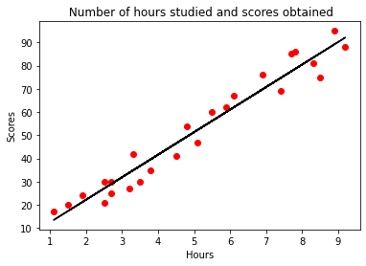

Make Predictions
In [89]:
print(x_test)
y_pred= model.predict(x_test)
[[8.3]
[2.5]
[2.5]
[6.9]
[5.9]
[2.7]
[3.3]
[5.1]]
In [87]:
results= pd.DataFrame({'Actual scores': y_test.ravel(),'Predicted scores': y_pred.ravel()})
results
Out[87]:
 | Actual scores | Predicted scores
0 | 81 | 83.391686
1 | 30 | 27.070549
2 | 21 | 27.070549
3 | 76 | 69.796929
4 | 62 | 60.086388
5 | 25 | 29.012657
6 | 42 | 34.838982
7 | 47 | 52.317955
In [82]:
Hours=9.25
result= model.predict([[9.25]])
print('The predicted score is ', result)
The predicted score is [[92.61670034]]

Evaluate the Model
In [86]:
from sklearn import metrics
print('Mean Absolute Error:',metrics.mean_absolute_error(y_test,y_pred))
print('Mean Squared Error:',metrics.mean_squared_error(y_test, y_pred))
print('R-2r:',metrics.r2_score(y_test, y_pred))
Mean Absolute Error: 4.499999999999998
Mean Squared Error: 23.61945761415174
R-2r: 0.9487647340257012

